**Project Design Phase – II**

**Data Flow Diagrams & User Stories**

|  |  |
| --- | --- |
| **Date** | 19-October 2022 |
| **Team ID** | PNT2022TMID05082 |
| **Project Name** | Inventory Management System for Retailers |
| **Maximum Marks** | 4 Marks |

**Data Flow Diagrams:**

A Data Flow Diagram (DFD) is a traditional visual representation of the information flows within a system. A neat and clear DFD can depict the right amount of the system requirement graphically. It shows how data enters and leaves the system, what changes the information, and where data is stored.

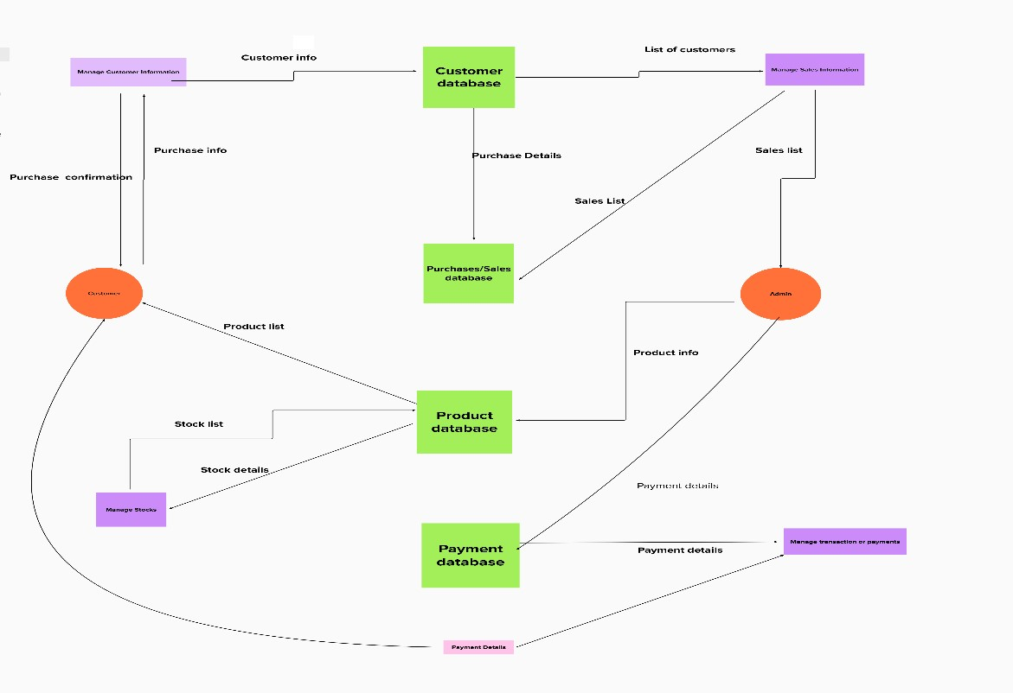

**User Stories:**

Use the below template to list all the user stories for the product.

|  |  |  |  |  |  |  |
| --- | --- | --- | --- | --- | --- | --- |
| **User Type** | **Functional**  **Requirement**  **(Epic)** | **User**  **Story**  **Number** | **User Story / Task** | **Acceptance criteria** | **Priority** | **Release** |
| Customer  (Mobile user & Web user) | Registration | USN - 1 | As a user, I can register for the application by entering my email, password & confirming my password. | I can access my account / dashboard. | High | Sprint - 1 |
|  |  | USN - 2 | As a user, I can see if there is any underflow or overflow. If there is underflow condition, I can order products, otherwise I can eliminate the stock which is not in large usage. | I can see the conditions of stock. | Low | Sprint – 2 |
|  |  | USN - 3 | As a user, I can manage sales information and manage transactions/payments. | I can manage sales information and manage transactions/payments. | Medium | Sprint – 2 |
|  | Login | USN - 4 | As a user, I can login to product database and see the information about product. | I can login to product database and see the information. | High | Sprint – 1 |
|  | Dashboard | USN - 5 | As a user, I can create a database credentials and enter my stocks. | I can create a database credentials and enter my stocks. | High | Sprint – 4 |
| Customer Care  Executive |  | USN – 6 | As a customer care executive, I can solve the log in issues and other issues of the application. | I can provide support or  solution at any time 24*7 | High | Sprint – 3 |
| Administrator | Application | USN - 7 | As a user, I can create alerts to require stocks. | I can manage the alerts on the stocks. | High | Sprint - 4 |